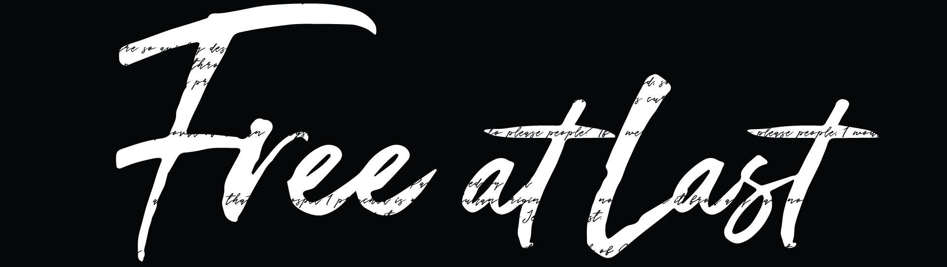

Free at Last - Part 5
“My Own Worst Enemy”
Pastor Dave Patterson
6-16,17-18
USING THIS SERMON DISCUSSION GUIDE

We have provided all the Scriptures referenced in the sermon and some discussion questions for you to use to facilitate a discussion.

This Sermon Discussion Guide is only a tool to aid you in meeting the needs of your group. For most groups, there are too many questions to answer in one session together.

While the questions are important, remember your group’s goal is not to pound through the questions but to create an atmosphere that will foster true friendships, so use the discussion questions as you see fit, but emphasize the relationships.
GOD SAID I AM:

“I am the righteousness of God in Christ” (2 Cor. 5:21)
“I am being changed from Glory to Glory into His image” ( 2 Cor 3:18)
“I am above an not beneath” (Deut. 28:13)
“I am an heir of eternal life” (Titus 3:7)
“I am not moved by what I see” (2 Cor 4:18)
“I am blessed with every spiritual blessing” (Ephesians 1:3)

“I am more than a conqueror” (Rom 8:37)
“ I am the light of the world and the salt of the earth” (Matt 5:14)
“I have the ‘Greater one’ in me and I overcome the devil” (1 John 4:4)
“I am blessed coming in and blessed going out” (Deut 28:6)
“I am healed by His stripes” (1 Peter 2:24 )
“I am a child of God” (1 John 3:1)

Key verse for the book

Galatians 5:1 The Passion Translation (TPT)
Let me be clear, the Anointed One has set us free—not partially, but completely and wonderfully free! We must always cherish this truth and stubbornly refuse to go back into the bondage of our past.

Galatians 5:2-4
Listen! I, Paul, tell you this: If you are counting on circumcision to make you right with God, then Christ will be of no benefit to you. I’ll say it again. If you are trying to find favor with God by being circumcised, you must obey every regulation in the whole law of Moses. For if you are trying to make yourselves right with God by keeping the law, you have been cut off from Christ! You have fallen away from God’s grace.

Galatians 5:7-10,
You were running a good race. Who cut in on you to keep you from obeying the truth?
It certainly isn’t God, for he is the one who called you to freedom.
This false teaching is like a little yeast that spreads through the whole batch of dough! I am trusting the Lord to keep you from believing false teachings. God will judge that person, whoever he is, who has been confusing you.

Galatians 5:12 Amplified Bible (AMP)
I wish that those who are troubling you [by teaching that circumcision is necessary for salvation] would even go all the way and castrate themselves!

Romans 7:15, 18-19,21-24
The trouble is with me, for I am all too human, a slave to sin. I don’t really understand myself, for I want to do what is right, but I don’t do it. Instead, I do what I hate.
And I know that nothing good lives in me, that is, in my sinful nature.^{[d]} I want to do what is right, but I can’t. I want to do what is good, but I don’t. I don’t want to do what is wrong, but I do it anyway.
I have discovered this principle of life—that when I want to do what is right, I inevitably do what is wrong. I love God’s law with all my heart. But there is another power^{[e]} within me that is at war with my mind. This power makes me a slave to the sin that is still within me. Oh, what a miserable person I am! Who will free me from this life that is dominated by sin and death?
Thank God! The answer is in Jesus Christ our Lord.

Galatians 5:16-26
So I say, walk by the Spirit, and you will not gratify the desires of the flesh. For the flesh desires what is contrary to the Spirit, and the Spirit what is contrary to the flesh.
These two forces are constantly fighting each other, so you are not free to carry out your good intentions.
But if you are led by the Spirit, you are not under the law. The acts of the flesh are obvious: sexual immorality, impurity and debauchery; idolatry and witchcraft; hatred, discord, jealousy, fits of rage, selfish ambition, dissensions (conflict with people) , division and envy; drunkenness, orgies, and the like. I warn you, as I did before, that those who live like this will not inherit the kingdom of God.
But the fruit of the Spirit is love, joy, peace, patience, kindness, goodness, faithfulness, gentleness and self-control. Against such things there is no law. Those who belong to Christ Jesus have crucified the flesh with its passions and desires. Since we live by the Spirit, let us keep in step with the Spirit. Let us not become conceited, or provoke one another, or be jealous of one another.

3 Ways to Live Victoriously

- Stay in Communion

“Since we live by the Spirit, let us keep in step with the Spirit”

2 Corinthians 13:14
The grace of the Lord Jesus Christ, and the love of God, and the communion of the Holy Spirit be with you all. Amen.

- Develop Consistency

- Commit to Living in Community

Galatians 5:25. (TVT)
Now since we have chosen to walk with the Spirit, let’s keep each step in perfect sync with God’s Spirit. This will happen when we set aside our self-interests and work together to create true community instead of a culture consumed by provocation, pride, and envy.

Galatians 5:13 (MSG)
It is absolutely clear that God has called you to a free life. Just make sure that you don’t use this freedom as an excuse to do whatever you want to do and destroy your freedom. Rather, use your freedom to serve one another in love; that’s how freedom grows.

Ezekiel 36:26
“And I will give you a new heart, and I will put a new spirit in you. I will take out your stony, stubborn heart and give you a tender, responsive heart, And I will put my Spirit in you”

TALK IT THROUGH

- As we continue in our series on freedom, share with your group an area from which God has set you free. Recount the victory with friends.

- We celebrate every victory over old hang-ups, but if we’re honest, we all experience temptation to go back to some habit or old way of thinking. What tries to reel you back when you’re walking in victory? What’s an area where you need to take a stubborn stand?

- The Apostle Paul found a road to enduring victory. Read Galatians 5:16-26 together and discuss the provision God has given. How can we experience a greater walk with the Holy Spirit? What are practical ways we can foster that heart-to-heart connection?

- Pastor Dave said, “Who you feed will win. Who you starve will lose.” What are some practices we need to develop into our lives to help “starve” the old nature? What’s the difference between consistency as a “rule” and consistency as a response to grace?

- What benefits have you experienced, spiritually, from walking in community? Has it always been easy to be transparent? What compels you to live an open life?

- Discuss Paul’s caution in Galatians 5:13. How can our freedom be used to serve others this week?

